
Marking key Task Five: Circulatory System (28 marks)

1 | C
2 | C
3 | B
4 | A
5 | C

6. Describe three of the functions of blood
Description | Mark
Any of the following: transporting oxygen and nutrients to the cells in the body, transporting carbon dioxide and other waster products away from the cells, transporting chemical messengers (hormones) to the cells, maintaining pH of body fluids, distributing heat and maintaining body temperature, maintaining water content and ion concentration of body fluids, protecting against disease-causing microorganisms, clotting when vessels are damaged to prevent blood loss. | 3
 | /3

7. What are the components of blood?
Description | Mark
Plasma | 1
Cell fragments called formed elements | 1
 | /2

8. Why does blood return to the heart?
Description | Mark
As blood pumped by the heart flows through tiny capillaries in the lungs or in the rest of the body, it loses most of its pressure. | 1
After going through the lungs, the blood pressure is so low that the blood must return to the heart to be pumped again before going to the rest of the body. | 1
 | /2

9. Why are the walls of veins thinner than in arteries?
Description | Mark
Veins have low relative blood pressure compared to arteries | 1
Veins have thin walls with little muscle compared to arteries | 1
 | /2

10. Label the diagram below.
Description | Mark
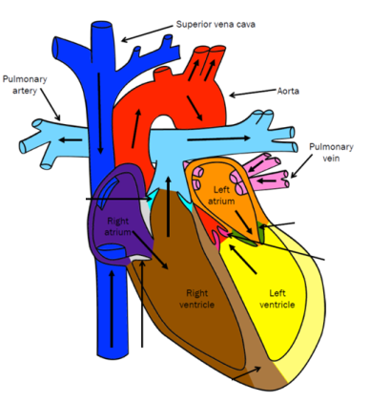 | 8
 | /8

11. Identify and describe one disease that affects the circulatory system. Include reference to symptoms and treatments.
Description | Mark
Identification and description- 2. Symptoms- 2. Treatments-2.
Atherosclerosis: found in most major arteries. Caused by high fat diet, high cholesterol, smoking, obesity and diabetes. Plaque build-up interferes with blood circulation in the heart and brain. A blockage can lead to heart attack or stroke.
 | /6

